**Summary:**

**Code Images:**

**Explanation:** This is the main.py program. This python file is the file that runs the entire application and runs as a “hub”. We separated my different functions into separate modules and they are imported above. First, we create a variable tweets.txt which is the name of the file the tweets will be saved too. We create our app instance and define our only route, which is the home page. We render the home.html file which has an html form. When the user submits the form it comes in the form of a POST call which in turn collects the twitter username and runs the twitter function to get the tweets, clean function to clean the tweets of punctuation, and getPlarity to get the polarity score and mood of the tweets. We then call buildResponse to build sentence that will be outputted to the user along with assigning an appropriate emoji. Once we have the response and emoji, we pass it onto the render_template function to render the results.html page and pass along the response we generated and emoji to the page.

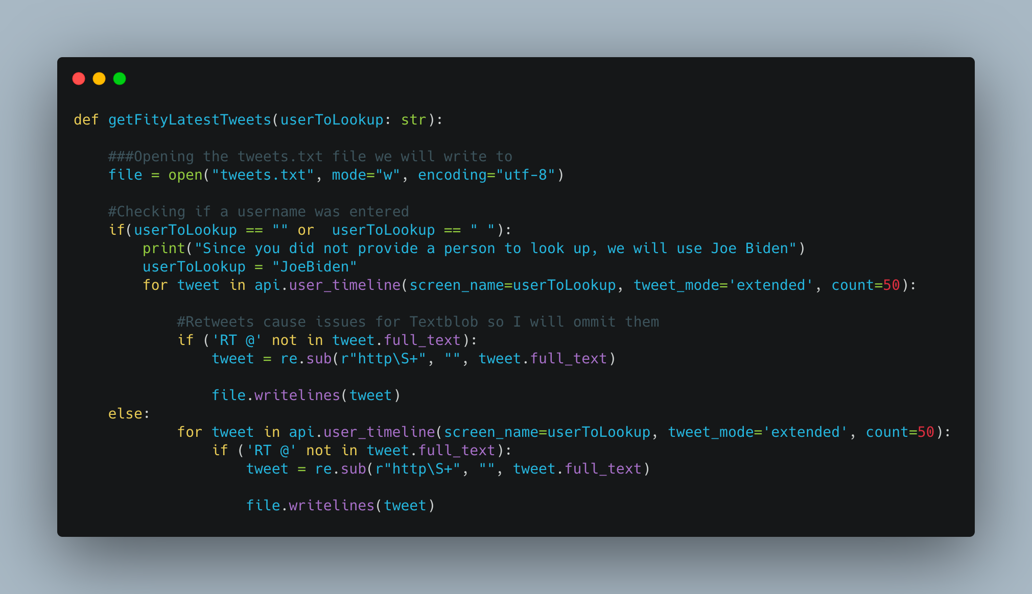

**Explanation:** This is the twitter.py file. The only part excluded from the screenshot is the API keys. Essentially the function getFiftyLatestTweets takes the input of a string of a user to lookup. It opens tweets.txt and checks if a user was inputted, it searches for the first fifty tweets by that user and if the tweets contains links, it is stripped (To not confuse Textblob). Then the tweet is written to tweets.txt. Over the course of debugging we realized encoding in UTF-8 was critical to ensure there were no errors in reading characters.

**Explanation:** This is from cleanup.py. The function cleanUpText takes in a string of the file to clean. It opens the file with utf-8 encoding and for each word, it utilizes the table variable as a table of punctuation to check against. String.puncuation comes with a lot of built-in punctuation marks so it acts as a giant list. Using .translate We check each word that could contain punctuation and strip it if It contains punctuation. Essentially this acted similar to a V-Lookup table.

**Explanation:** This is from home.html. Most of the page is self explanatory, but what is important to note is the three buttons for Joe Biden, CNN, NJ.COM. Those buttons will fill in the username field since they act as suggestions if you can’t think of who to analyze. Those three buttons fire off the three functions above to fill in the one text box field.

**More Ideas:**